LAB CYCLE 4

EXPERIMENT 1

AIM :
Write a program to print the Fibonacci series using recursion.

SOURCE CODE :
def fibonacci(n):
if n<=1 :
return n
else :
return fibonacci(n-1)+fibonacci(n-2)
num=int(input("Enter the number of terms :"))
if num<0 :
print("\nplease enter a positive integer ")
else :
print("\nFibonacci series :")
for i in range(num):
print(fibonacci(i),end=' ')
print("\n")

OUTPUT:

Enter the number of terms :10

Fibonacci series :
0 1 1 2 3 5 8 13 21 34

Enter the number of terms :-1

please enter a positive integer

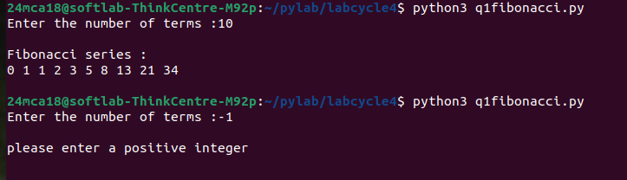

EXPERIMENT 2

AIM :
Write the to implement a menu-driven calculator. Use separate functions for the different operations.
SOURCE CODE :
def addition(a,b):
return a+b
def subtraction(a,b):
return a-b
def multipliction(a,b):
return a*b
def division(a,b):
return a/b
a=int(input("Enter the first number :"))
b=int(input("Enter the second number :"))
while True :
print("\n1.Addition\n2.Subtraction\n3.Multiplication\n4.Division\n5.Exit")
c=input("\nEnter your choice :")
if c=='5':
break;
elif c=='1':
print(f"\n{a} + {b} = {addition(a,b)}\n")
elif c=='2':
print(f"\n{a} - {b} = {subtraction(a,b)}\n")
elif c=='3':
print(f"\n{a} * {b} = {multipliction(a,b)}\n")
elif c=='4':
print(f"\n\n{a} / {b} = {division(a,b)}\n")
else :
print("\nInvalid Choice !!\n")

OUTPUT:

Enter the first number :6
Enter the second number :4

1.Addition
2.Subtraction
3.Multiplication
4.Division
5.Exit

Enter your choice :1

6 + 4 = 10

1.Addition
2.Subtraction
3.Multiplication
4.Division
5.Exit

Enter your choice :2

6 - 4 = 2

1.Addition
2.Subtraction
3.Multiplication
4.Division
5.Exit

Enter your choice :3

6 * 4 = 24

1.Addition
2.Subtraction
3.Multiplication
4.Division
5.Exit

Enter your choice :4

6 / 4 = 1.5

1.Addition
2.Subtraction
3.Multiplication
4.Division
5.Exit

Enter your choice :6

Invalid Choice !!

1.Addition
2.Subtraction
3.Multiplication
4.Division
5.Exit

Enter your choice :5

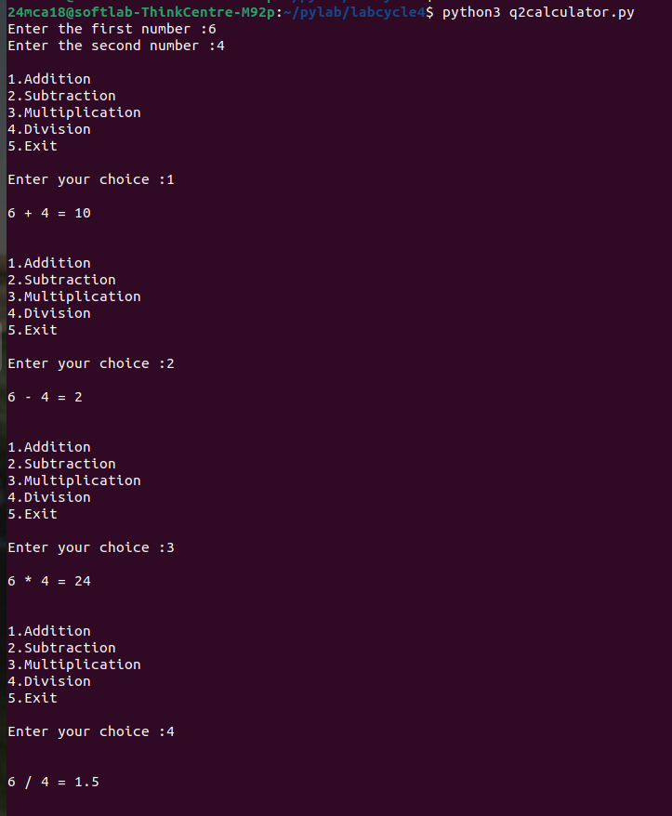

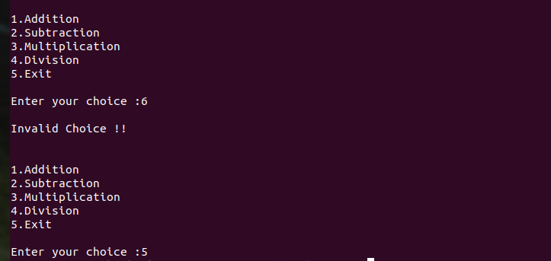

EXPERIMENT 3

AIM :
Write a program to print the nth prime number. [Use function to check whether a number is prime or not]
SOURCE CODE :
def is_prime(num):
if num<=1:
return False
for i in range(2,int(num**0.5)+1):
if num%i==0:
return False;
return True
def nth_prime(n):
count=0
num=2
while True:
if is_prime(num):
count+=1
if count+1==n:
return num
num+=1
n=int(input("Enter the value of n to find the nth prime number:"))
if n<=0:
print("\nPlease enter a positive integer.")
else:
result=nth_prime(n)
print(f"\nThe {n}th prime number is: {result}")

OUTPUT:
Enter the value of n to find the nth prime number:5

The 5th prime number is: 11

Enter the value of n to find the nth prime number:-1

Please enter a positive integer.

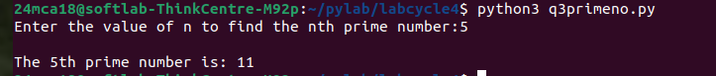
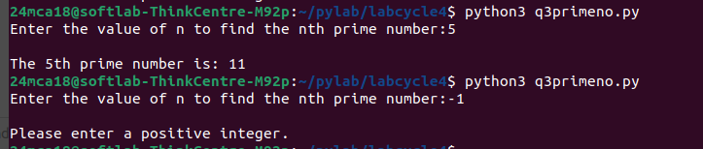

EXPERIMENT 4

AIM :

Write lambda functions to find the area of square, rectangle and triangle.

SOURCE CODE :

area_square=lambda side:side*side
area_rectangle=lambda length,breadth:length*breadth
area_triangle=lambda base,height:0.5*base*height
side=float(input("Enter the side of square in centimetres : "))
print("Area of Square :",area_square(side),"sq.cm")
length=float(input("\nEnter the length of rectangle in centimetres : "))
breadth=float(input("Enter the breadth of rectangle in centimetres : "))
print("Area of Rectangle :",area_rectangle(length,breadth),"sq.cm")
base=float(input("\nEnter the base of triangle in centimetres : "))
height=float(input("Enter the height of triangle in centimetres : "))
print("Area of Triangle :",area_triangle(base,height),"sq.cm")

OUTPUT:
Enter the side of square in centimetres : 4
Area of Square : 16.0 sq.cm

Enter the length of rectangle in centimetres : 4
Enter the breadth of rectangle in centimetres : 6
Area of Rectangle : 24.0 sq.cm

Enter the base of triangle in centimetres : 4
Enter the height of triangle in centimetres : 6
Area of Triangle : 12.0 sq.cm

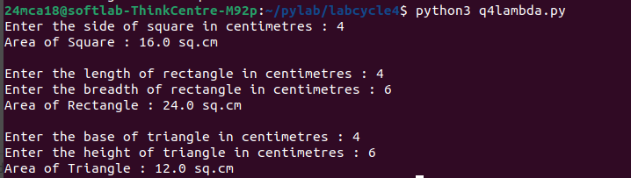

EXPERIMENT 5

AIM :
Write a program to display powers of 2 using anonymous function. [ Hint use map and lambda function)
SOURCE CODE :
num = input("Enter a list of numbers separated by space: ")
n = num.split()
lst = []
for i in n:
lst.append(int(i.strip()))

powers_of_2 = list(map(lambda x: 2 ** x, lst))
print("Powers of 2:", powers_of_2)

OUTPUT:

Enter a list of numbers separated by space: 1 2 3 4 5
Powers of 2: [2, 4, 8, 16, 32]

EXPERIMENT 6

AIM :
Write a program to display multiples of 3 using anonymous function. [ Hint use filter and lambda function)

SOURCE CODE :
num = input("Enter a list of numbers separated by space: ")
n = num.split()
lst = [int(i.strip()) for i in n]

multiples_of_3 = list(filter(lambda x: x % 3 == 0, lst))
print("Multiples of 3:", multiples_of_3)

OUTPUT:

Enter a list of numbers separated by space: 1 2 3 4 5
Powers of 2: [2, 4, 8, 16, 32]

EXPERIMENT 7

AIM :
Write a program to sum the series 1/1! + 4/2! + 27/3! + ….. + nth term. [ Hint Use a function to find the factorial of a number].

SOURCE CODE :
def factorial(num):
if num==0 or num==1:
return 1
else:
result=1
for i in range(2,num+1):
result*=i
return result
def sum_series(n):
series_sum=0
for i in range(1,n+1):
term=(i**i)/factorial(i)
series_sum+=term
return series_sum
n=int(input("Enter a positive integer : "))
if n<0:
print("Please enter a positive integer . ")
else:
result=sum_series(n)
print(f"The sum of the series 1/1! + 4/2! + 27/3! + .... upto {n} terms is : {result}")

OUTPUT:

Enter a positive integer : 5
The sum of the series 1/1! + 4/2! + 27/3! + .... upto 5 terms is : 44.20833333333333
24mca18@softlab-ThinkCentre-M92p:~/pylab/labcycle4$ python3 q7series.py
Enter a positive integer : -2
Please enter a positive integer .

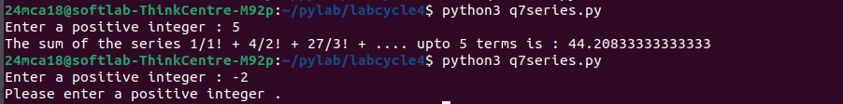

EXPERIMENT 8

AIM :

Write a function called compare which takes two strings S1 and S2 and an integer n as arguments. The function should return True if the first n characters of both the strings are the same else the function should return False.

SOURCE CODE :

def compare(s1,s2,n):
if s1[:n]==s2[:n]:
return True
else:
return False
s1=input("Enter first String:")
s2=input("Enter second String:")
n=int(input("Enter an integer:"))
result=compare(s1,s2,n)
if result==True:
print(f"The first {n} characters of both the strings are same.")
else:
print(f"The first {n} characters of both the strings are not same.")

OUTPUT:

Enter first String:apple
Enter second String:app
Enter an integer:2
The first 2 characters of both the strings are same.

Enter first String:anju
Enter second String:rajesh
Enter an integer:3
The first 3 characters of both the strings are not same.

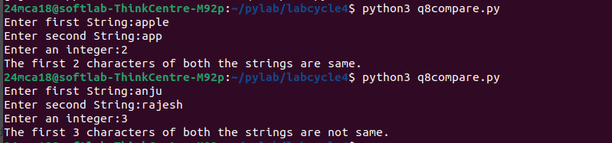

EXPERIMENT 9

AIM :

Write a program to add variable length integer arguments passed to the function. [Also demo the use of docstrings]

SOURCE CODE :

'''program to add variable length integer arguments
passed to the function 'add' and also to demonstrate
the use of docstrings '''
def add(*args):
return sum(args)
n=int(input("Enter the number of elements:"))
l=[]
for i in range(n):
a=int(input("Enter a number:"))
l.append(a)
result=0
for i in l:
result=result+i
print("The sum is:", result)

OUTPUT:

Enter the number of elements:5
Enter a number:1
Enter a number:2
Enter a number:3
Enter a number:4
Enter a number:5
The sum is: 15

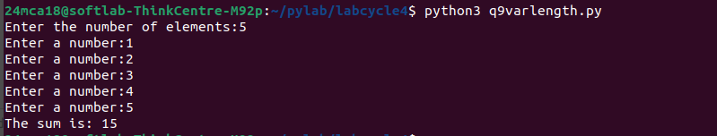

EXPERIMENT 10

AIM :

Write a program using functions to implement these formulae for permutations and combinations. The Number of permutations of n objects taken r at a time: p(n, r) = n!/(n − r)!. The Number of combinations of n objects taken r at a time is: c(n, r) = n!/(r! ∗ (n − r)!)

SOURCE CODE :

def factorial(n):
if n==0 or n==1:
return 1
else:
return n*factorial(n-1)
def permutation(n,r):
return factorial(n)/factorial(n-r)
def combination(n,r):
return factorial(n)/(factorial(r)*factorial(n-r))
n=int(input("Enter the value of n:"))
r=int(input("Enter the value of r:"))
print(f"The number of permutaions of {n} objects taken {r} at a time : p({n},{r}) = {n}!/({n}-{r})! = {permutation(n,r)}")
print(f"The number of Combinations of {n} objects taken {r} at a time : c({n},{r}) = {n}!/({r}! * ({n}-{r})!) = {combination(n,r)}")

OUTPUT:

Enter the value of n:4
Enter the value of r:2
The number of permutaions of 4 objects taken 2 at a time : p(4,2) = 4!/(4-2)! = 12.0
The number of Combinations of 4 objects taken 2 at a time : c(4,2) = 4!/(2! * (4-2)!) = 6.0

